Future Icons Selects – 10-14 May 2023

You’re invited to apply for Future Icons Selects curated by Louisa Pacifico of Future Icons. For this edition we are seeking to showcase up to 100 contemporary makers across Oxo Tower Wharf’s iconic Bargehouse building.
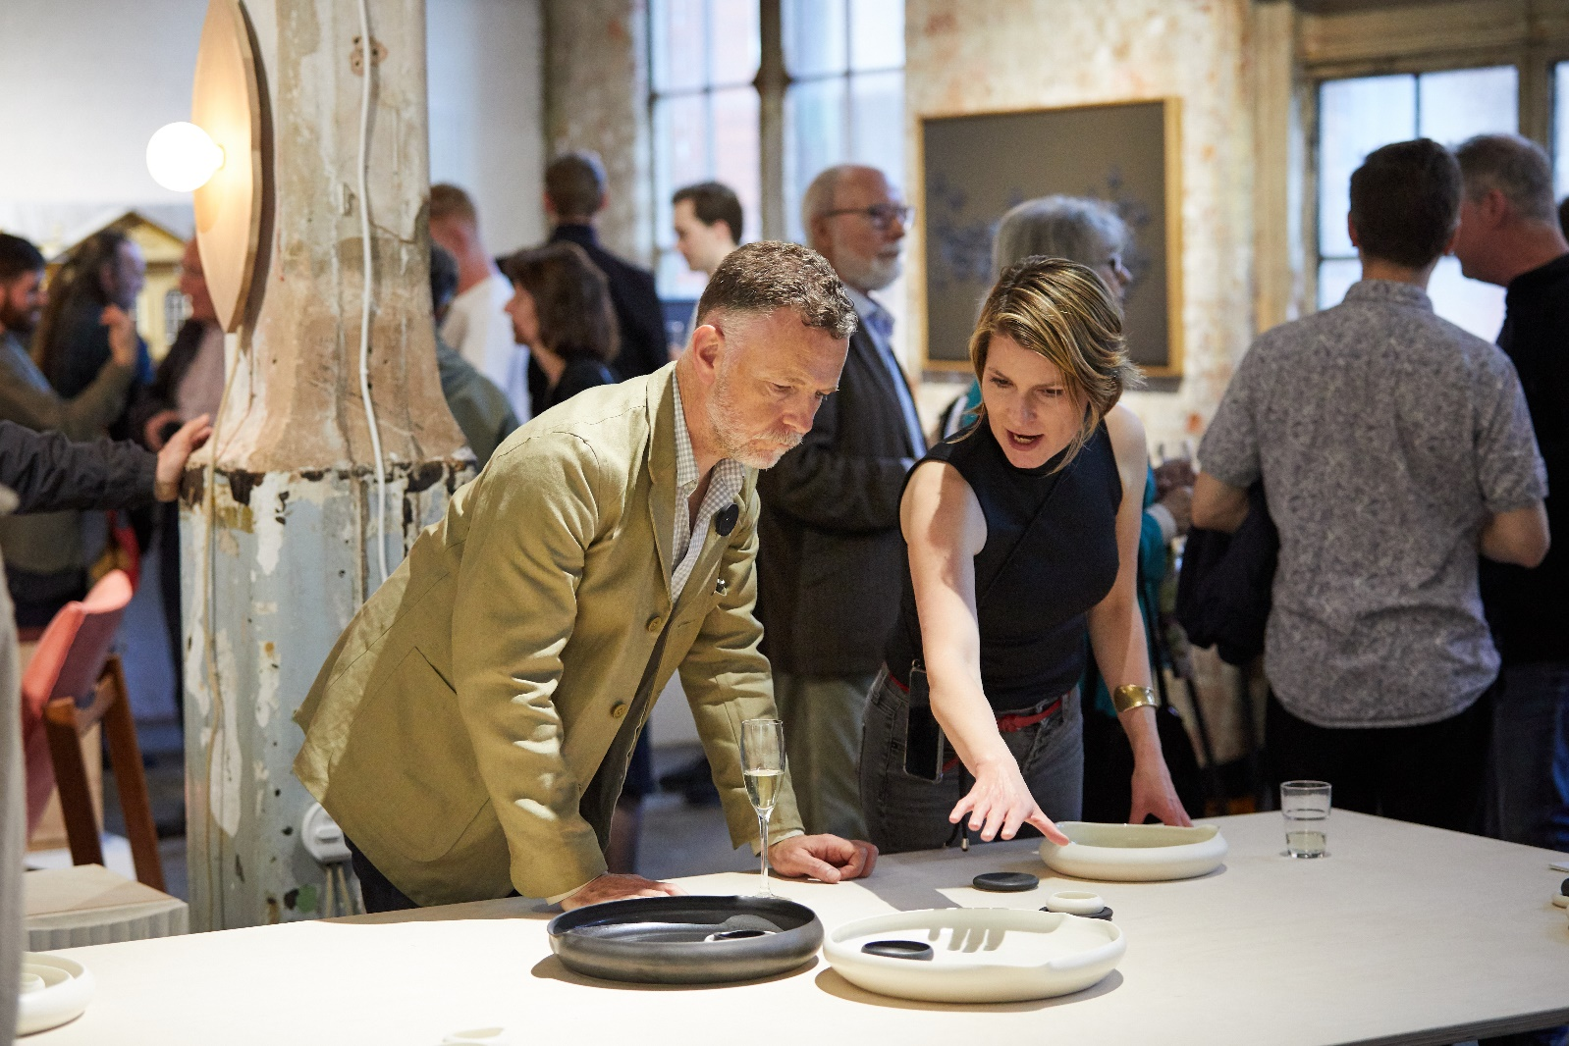

Traditionally, we showcased members from Future Icons at Oxo Tower Wharf’s show; The Future of Craft. This event hosted a number of organisations and collectives in separate rooms, which has attracted over 2000 visitors across our private view and 4 public viewing days. To take it to the next level, we have decided to take over the entire venue and curate each room with multidisciplinary craft makers, a journey of discovery for visitors.
We are looking to showcase a strong cross section of contemporary craft, focusing on materiality, process and original design. We want our visitors to be ‘wowed’ by the breadth of talent within our industry – so all applications will be considered.
We are also looking to host a pre-paid workshop area for makers to provide 2h taster workshops in. This will be an opportunity for you to recoup your exhibiting fee.

Application Form
This will be a large community project to ensure we gain footfall from galleries, private collectors, commercial brands and press, therefore we have a few simple conditions for the selected applicants.
Are you willing to:
- Install your work yourself between 8-10 May 2023 (some assistance will be on hand during build up)
- Make good of the space you have used when dismantling the show on 15 May 2023
- Possibly provide your own plinth (if required)
- Market your presence with us through social media and mailing lists
- Be present for all open days – you are your own best sales person (Private view 10 May / Public days 11-14 May 2023)
If the answer is YES – then please read on! – DEADLINE 31/1/2023
Cost of exhibiting: £650 – this includes your dedicated exhibition area and maker listing on the London Craft Week website. We aim to let you know if your application has been successful by 1/2/23. Payment due 1/3/23.

Please fill in the following details and up to 4 images of the proposed work
Contact Details
Full Name: _______________________________________ Company Name: _________________________________________
Number and Street Address: _________________________________________________________________________________
City: ______________________________ County: _____________________________ Postcode:__________________________
Telephone: ______________________________ Email: ___________________________________________________________
Website/s:________________________________________________________________________________________________
Instagram:________________________________________ LinkedIn:________________________________________________
Would you be interested in hosting a pre-paid workshop? Y / N – If yes, please provide details below:
_________________________________________________________________________________________________________
_________________________________________________________________________________________________________
_________________________________________________________________________________________________________
_________________________________________________________________________________________________________

Please provide details of the work/ installation you would like us to consider and the amount of space you require (max 100 words)
_________________________________________________________________________________________________________
_________________________________________________________________________________________________________
_________________________________________________________________________________________________________
_________________________________________________________________________________________________________
_________________________________________________________________________________________________________

Images: Please provide up to 4 images in JPEG format via wetransfer or Dropbox link with this application form to louisa@futureicons.co.uk – If selected, these will be used for press purposes. Good Luck!

