Future Icons Selects – 15-19 May 2024
You are invited to apply for Future Icons Selects curated by Louisa Pacifico of Future Icons. For this edition we are seeking to showcase 70+ contemporary makers across Oxo Tower Wharf’s iconic Bargehouse building.

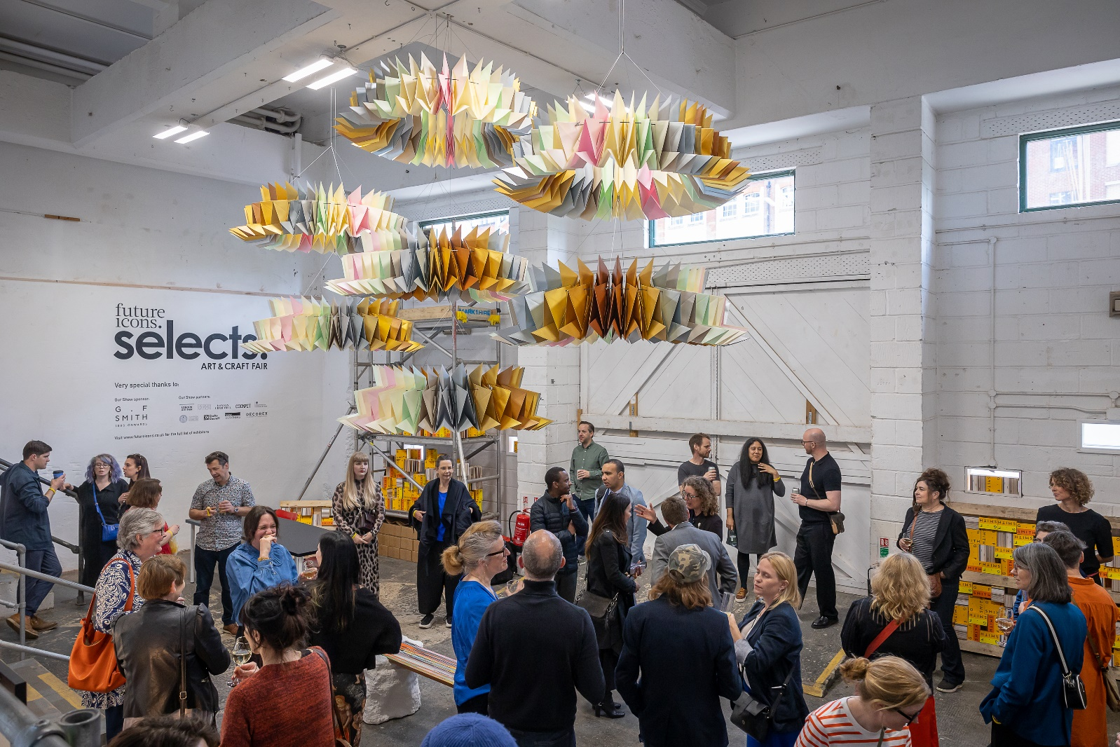

In May 2023, we launched the inaugural Future Icons Selects during London Craft Week. We welcomed over 2200 visitors across 4 days to view the collections by our 71 artisans. Feedback from exhibitors included that they sold works, gained bespoke commissions, connected with significant global brands for future projects and many of whom have now been featured in print and online press.
We are not like other events, we carefully curate every space within the Bargehouse to give visitors and exhibitors a unique and contemporary experience. We do not believe in boxing creatives into 3x2m spaces, our showcase places likeminded and premium makers together to allow our commercial and public visitors to visualise how they can work and live with your collections.
We are looking to showcase a strong cross section of contemporary craft, focusing on materiality, process and original design. We want our visitors to be ‘wowed’ by the breadth of talent within our industry – so all applications will be considered.

Venue: oxo tower wharf’s industrial Bargehouse, located on London’s iconic Southbank, SE1

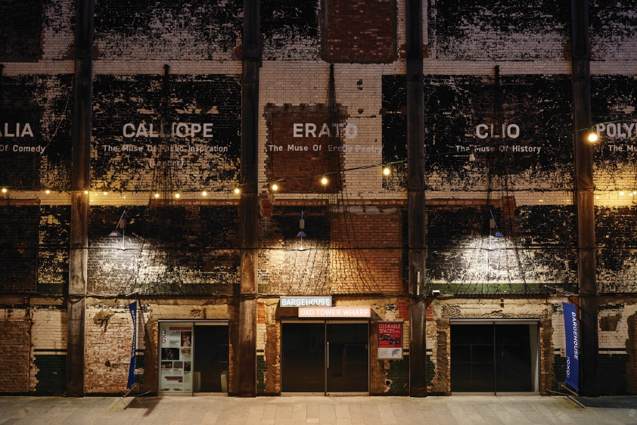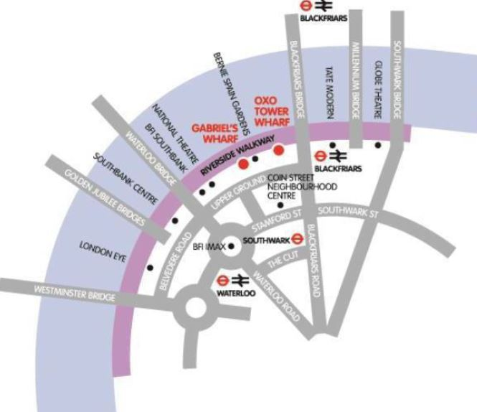

Bargehouse is an exciting space in London’s lively South Bank and Bankside areas. A vast, untouched five-storey building, in its raw state, Bargehouse is often transformed by creatives for unconventional exhibitions, immersive performance and interactive events.
With over 3000 square feet of industrial space to use, this venue provides us with a blank canvas with multiple backdrops for a wide range of installations.
This venue has been in use since 2019 for London Craft Week, and the owners promote their permanent design led studios and retailers during LCW to support footfall within this time period.

Opportunity to:
- Install wall-based art works
- Hang artwork and installations from the ceilings
- Showcase collections within floor space with a multitude of backdrops
- Create lighting installations within black-out rooms
- Present ideas for consideration. We are open to all suggestions!

Selected images from Future Icons Selects 2023

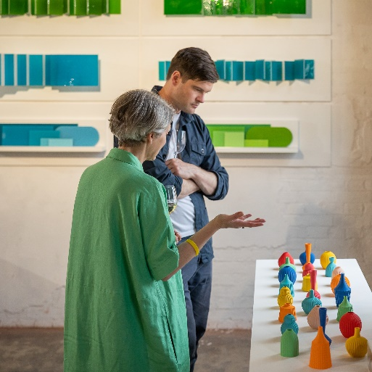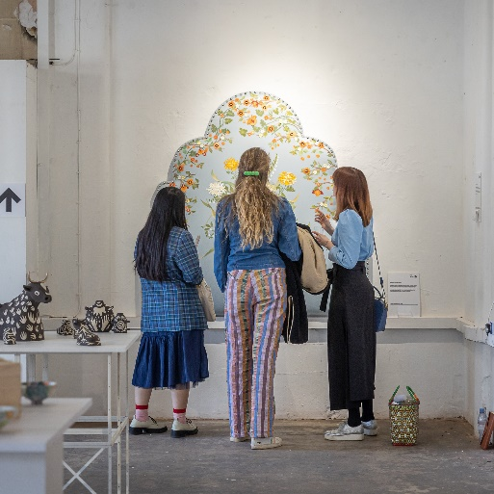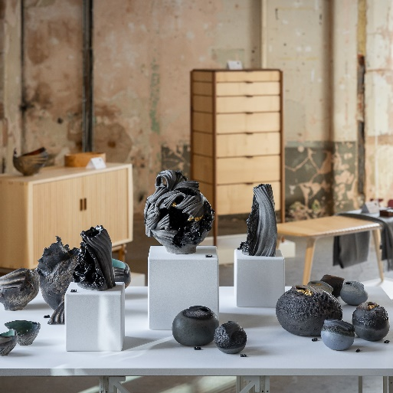

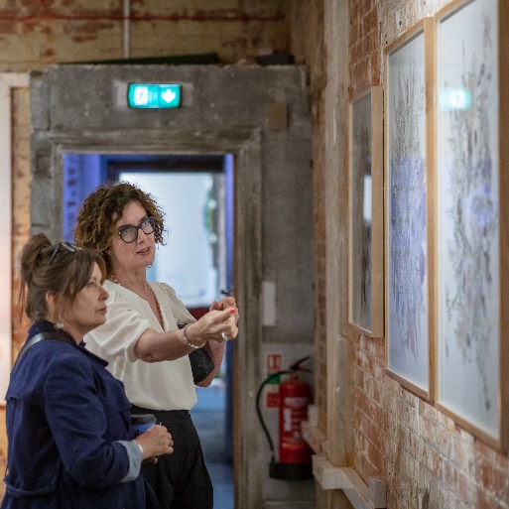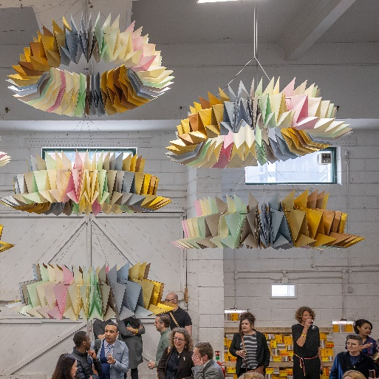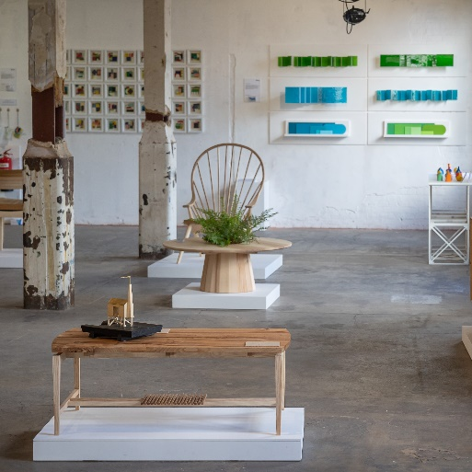

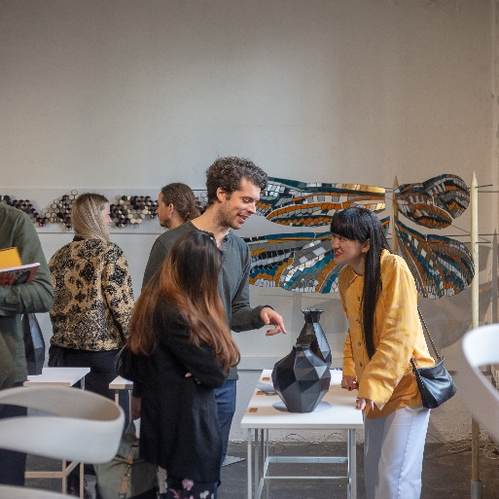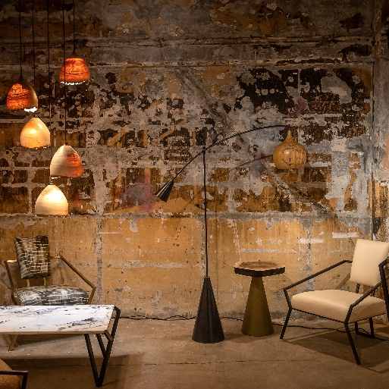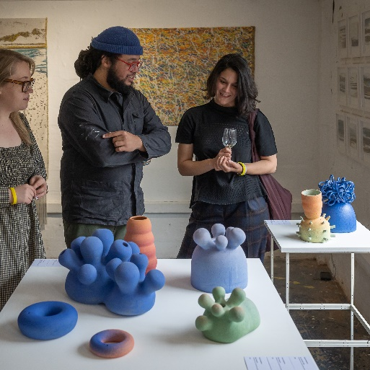

Application Form
This will be a large community project to ensure we gain footfall from galleries, private collectors, commercial brands and press, therefore we have a few simple conditions for the selected applicants.
Are you willing to:
- Install your work yourself between 14-15 May 2024 (some assistance will be on hand during build up)
- Make good of the space you have used when dismantling the show on 20 May 2024
- Possibly provide your own plinth (if required)
- Market your presence with us through social media and mailing lists
- Be present for all open days – you are your own best sales person (Private view 15 May / Public days 16-19 May 2024)
If the answer is YES – then please read on! – DEADLINE 3/11/2024
Cost of exhibiting: £800 – this includes your dedicated exhibition area and maker listing on the London Craft Week website. We aim to let you know if your application has been successful by 1/12/23. Non-refundable 20% deposit required 15/12/23. Final 80% payment due 1/2/24.

Please contact Louisa Pacifico via louisa@futureicons.co.uk or 0044 (0) 7838102031 if you have any questions prior to applying. Please note, Louisa will be on annual leave 29 September – 5 October 2023.

Please fill in the following details and attach up to 4 JPEG format images of the proposed work

Contact Details
Full Name: Company Name:
Number and Street Address:
City: County: Postcode:
Telephone: Email:
Website/s: Instagram:

Please provide details of the work/ installation you would like us to consider and the amount of space you require (max 100 words)

Images: Please provide up to 4 images in JPEG format via wetransfer or Dropbox link with this application form to louisa@futureicons.co.uk – If selected, these will be used for press purposes. Good Luck!

